SUBMITTED TO:

Sir junaid:

***Multiclass ANN problem Solving Report***

**REPORT:**

**Mutahara Ghulam Rasool (BSCS-2019-14)**

**Hamza Iqbal (BSCS-2019-10)**

## ACKNOLOGEMENT:

I would like to thank Dr. Junaid Akhtar for making this remarkable assignment for us. Before I started this assignment I was having difficulty of understanding this assignment because for the very first time I do not know what ANN is? Now that I have finished it I understood all these things. This assignment helped me to uplift my hypothesizing ability.

I would also like to thanks Mr. Ali Raza Khan for help me out in this project.

## Abstract:

Human can be called as the most efficient specie of this planet and it is quite much true. Therefore it wants to make this world to work accordingly to itself. When the things got complicated, and unable to solve by itself, it turned to computers which were much more fast and efficient to solve the problems of human. In today’s world, human is working upon the very same thing, to somehow make this thing more helpful to human. Looking at itself, human has got inspiration to make that thing work like him but much more efficient and intelligent. Here dives the concept of Artificial Intelligence. Artificial Intelligence is a term means make a machine to do work intelligently as we human do. The most important one is the Artificial Neural Network. In recent times, there has been a growing interest in artificial neural networks, which is nearly the simulation of human brain. Human brain has a network of neurons from where the idea of neural network comes. Most of our work is based upon the decision of brain, ANN is given intelligence of processing information and learn accordingly to our Brain.

# Natural Reality:

Under the context of a Human, the phenomenon of learning starts when it is born. As a toddler, human gets to interact with several things in its surroundings. When it sees them for the first time, it gets no idea, what that thing is. But as the time passes, someone from his parents or some other person makes a specific sound to call that thing. He listens to that voice but clearly don’t know what actually it is. As the time passes, when he hears same voices upon the same thing, he tries to make it call by expressing that similar sound. But as the time passes, it learns different aspects of these things by observing and comparing. And then, it becomes a habit to call that thing with a specific voice. Learning is basically to interact with the world by observing and with other senses.

## Theory Of Learning (Cognitivism):

There are various theories of learning that shows how learning starts and things comes to understand. Cognitivism is one the learning theory to understand the process of learning and is much related to our project. Cognitivism is the theory of learning in which the changes in the behavior are observed and processed to understand. It is majorly based on the learning through experience. In Cognitivism, the leaner’s mind is just like a mirror that reflects the knowledge it contains. As the time passes, changes in knowledge comes due to reorganization of experiences that are observed in that time. The whole process of learning depends on which type of external factors are impacting and how they are processed in the brain.

Some of the examples of cognitive learning are as follows:

* Classifying
* Linking the already present concepts
* Differentiation

## Extracting Computational Model:

On the basis of cognitive theory of learning, a computational model can be extracted to solve our multi class classification problem through the process of learning.

### Introduction:

A single neuron or perceptron is the building block of the whole neural network. Speaking up biologically, a single neuron is composed of three major parts. That includes dendrites, a cell body containing nucleus an axon. Dendrites functions to get information, that information is processed in cell body, and then decision is carried via axons.

### Model:

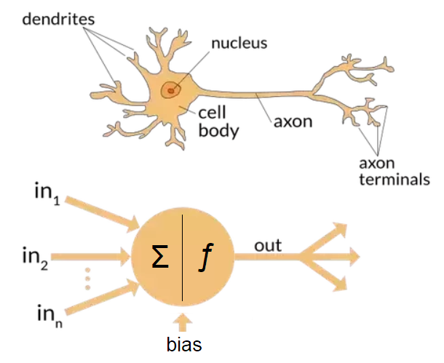Using a single neuron, we got the model of a perceptron. Looking at the brain neuron, the perceptron also comprised of three parts. There are various inputs that acts as dendrites. The inputs are then processed via the vector product of all the inputs. The output is gained via a step function. A single perceptron is used to solve the two class problem, means to differentiate one class form other. In this perceptron model we have to train the perceptron using inputs, and then, it works on its own to make decision. To solve the multiclass problem we have to use several neurons in an organized manner to solve. To solve them, there is a phenomenon of hidden layers. What hidden layers do is to process the input data accordingly to our implementation of each neuron of the hidden layers. 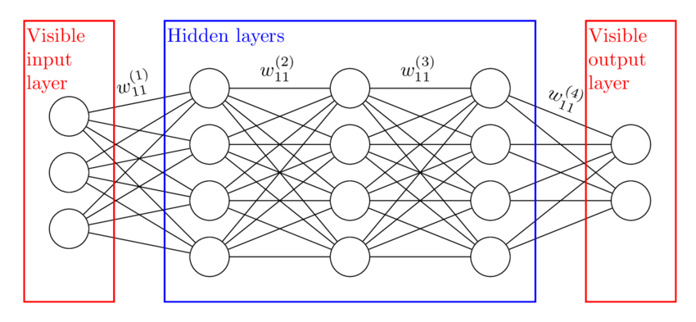

## Problem:

The problem we got was a multiclass distinguishing problem. We have been the datasets in the form of images containing the data of hundreds of handwritten numbers in roman. Each number has several images or can be said several ways of writing. 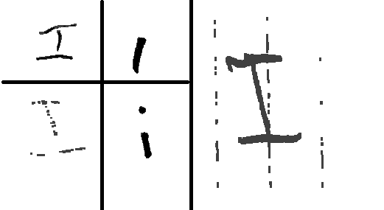The above figure is of the Roman Number One. There are two types of datasets. One of which is the data of images on which our model will be trained. The other one composed of data that will be given to the model to check whether our trained model is working correct approximately.

## Libraries For implementing the Model:

### OS:

OS is a library used to locate and access the files in various directories. We used the OS library to get the access the images of our training and validation datasets.

### Numpy:

Numpy is a very useful library in order to get the help during the utilization of arrays and lists. It helps to manipulate, read and summarizing the data.

### cv2:

cv2 is a module of OpenCV. It is helpful for the processing of images. In our case we used this module to read images that we get from OS library of the training ans validation datasets.

### Sklearn Library:

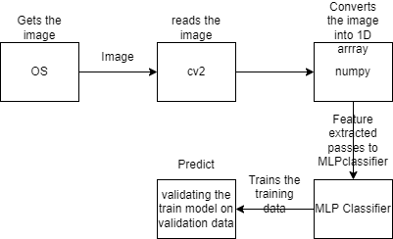Scikit-learn is a python library which is extremely useful for building the machine learning models in order to solve the problems related to the classification, regression and dimensionality reduction. As our problem is a multiclass we uses the module of MLPclassifier of the SKlearn library. Working of the model is as follows.

### 

“Code File is also attached”

## Experiments:

### Experiment 1:

To Check the correct working of the model, we set the following assumptions.

* Hidden Layers “1 with 100 neurons”
* Activation function “relu”
* Maximum iterations “50”
* Initial learning rate “0.00001”

The output we get was as follows:

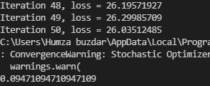

### Experiment 2:

Keeping in mind the output of the first experiment, assumingly we just changed the requirements for the MLP classifier. Keeping in mind that we are giving it only one feature that is the black portion of each image. The changes are as follows:

* Hidden Layers “3, each containing 500 neurons”
* Maximum iterations “500”

The results were quite satisfying with respect to the initial nature. The loss went dropped to 0.29. Means that there is a way for improvement. The results are as follows.

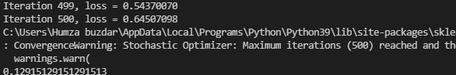

### Experiment 3:

In this experiment, we have made some major changes. We used the logistic activation function. The reason of that was to get some sigmoid representation which might turn to be helpful with respect to our dataset. The output as follows:

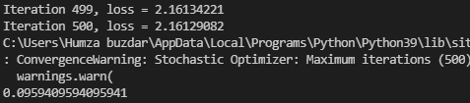

The results were quite surprising. But this also tells us the deficiency of logistic function. The gradient becomes very small and hinders the learning of the model. In contrast, ReLU using the sparse representation tries to learn faster till dying.

### Experiment 4:

So that there is a chance now that if we keep the settings of second experiment but increasing the hidden layers. So now, we have six hidden layers, five of which are composed of 500 neurons but the last layer composed of 100 neurons. The results are as follows.

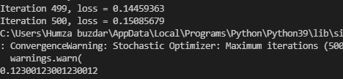

There is a slight improvement but that does not prove that increasing the hidden layers will work out for our problem.

So from above observations of our experiments we can say that the model is under fit. And there might be a chance to do it further correctly.